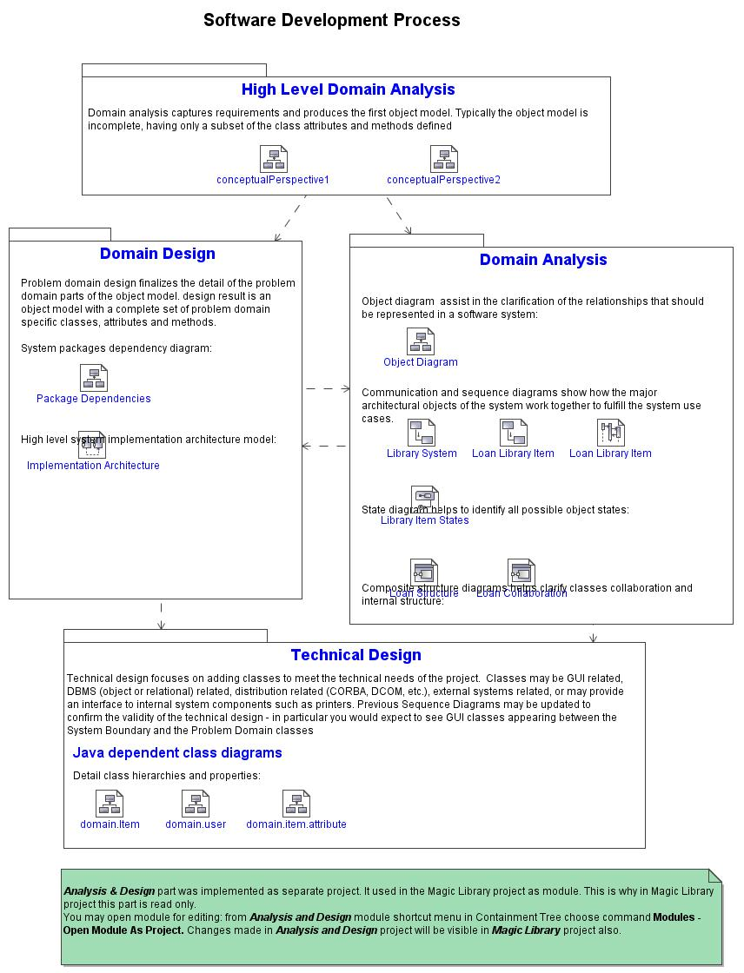
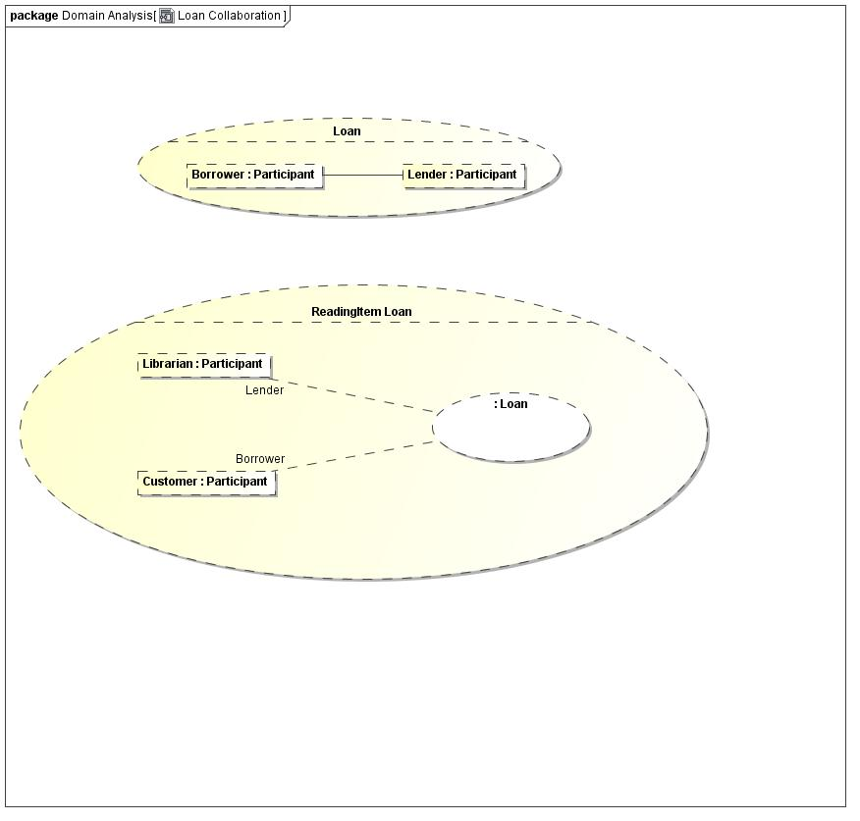
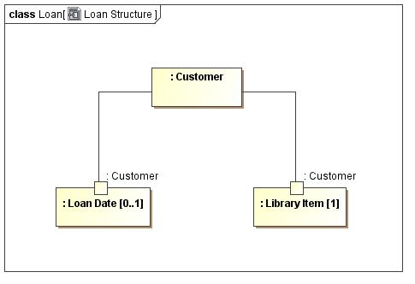
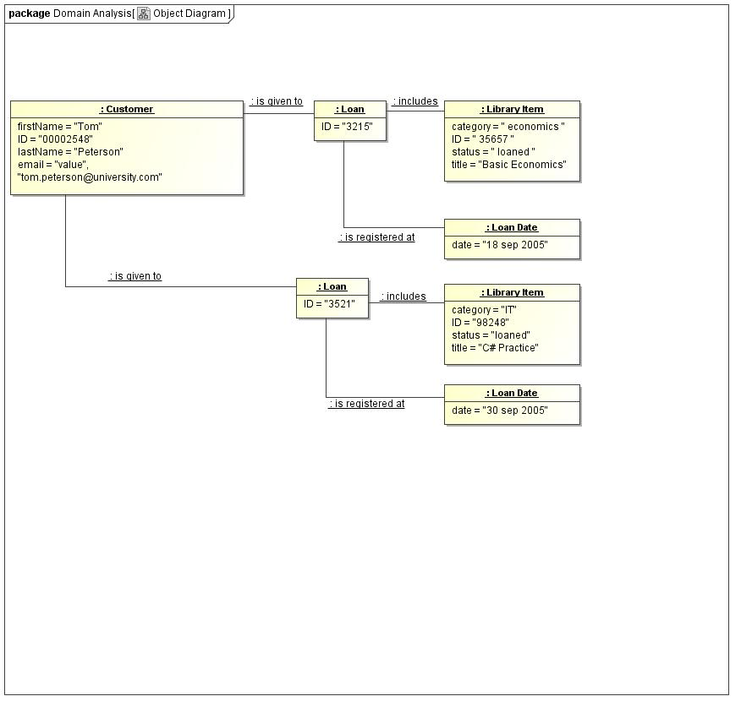
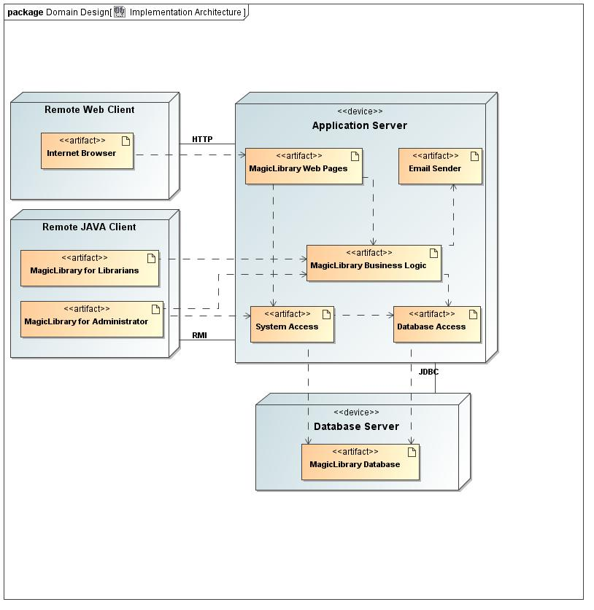
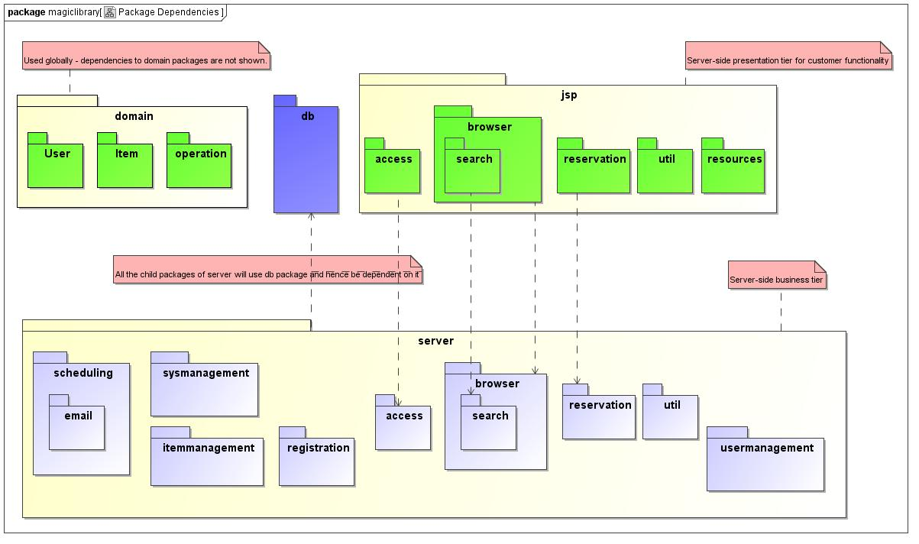
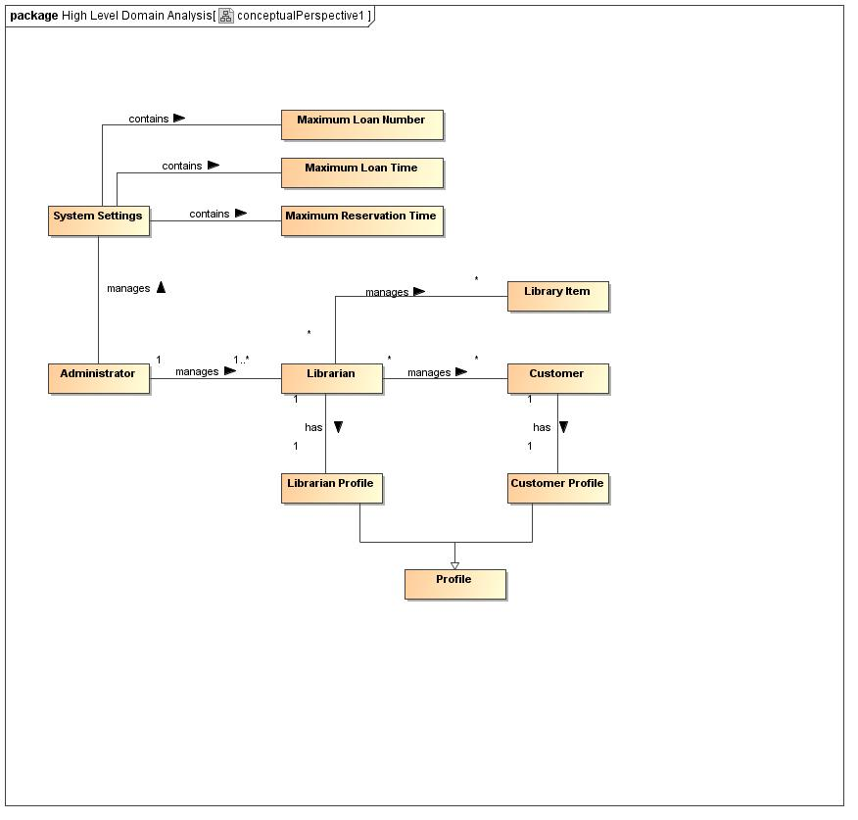
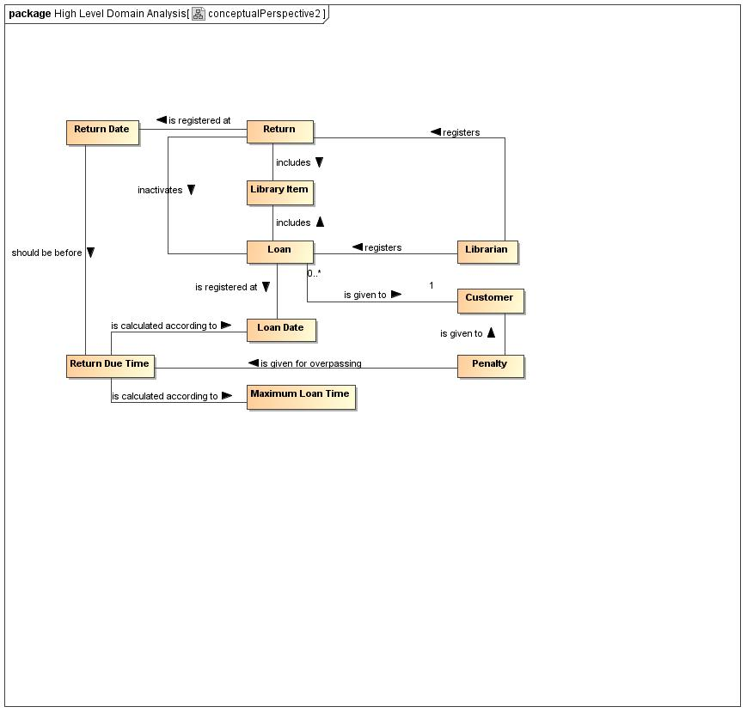
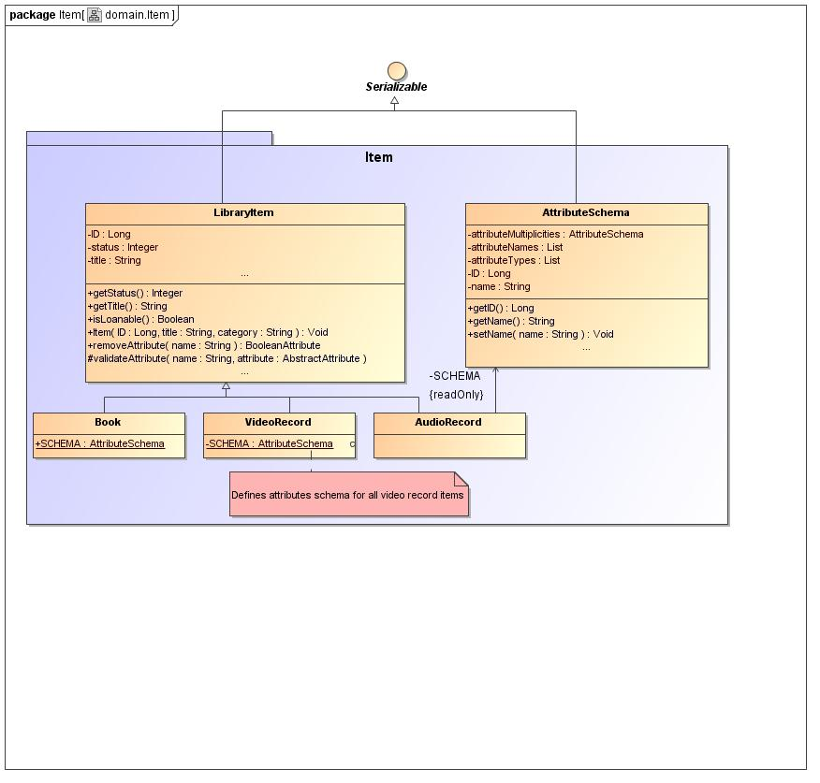
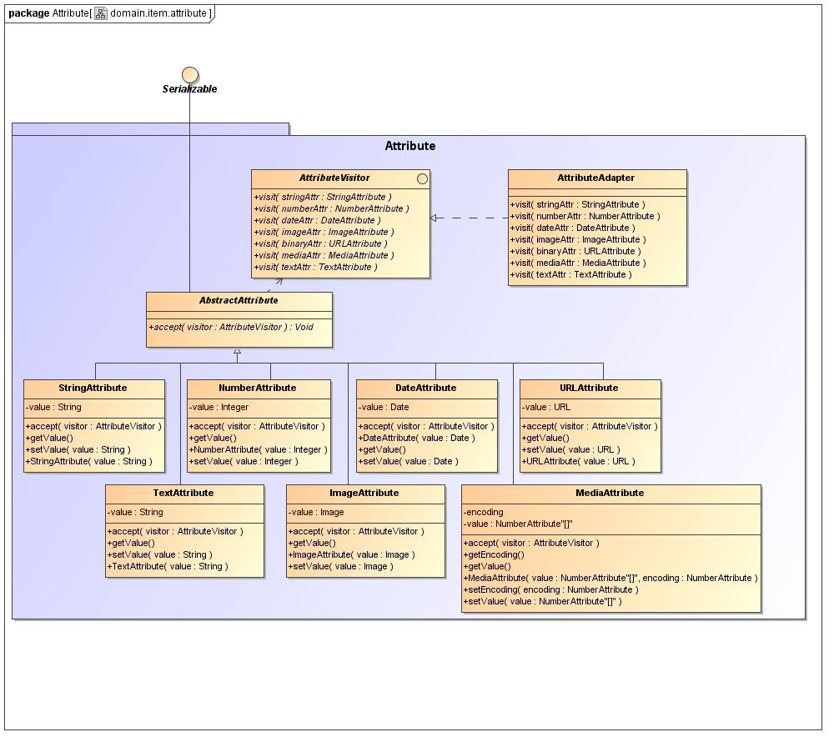
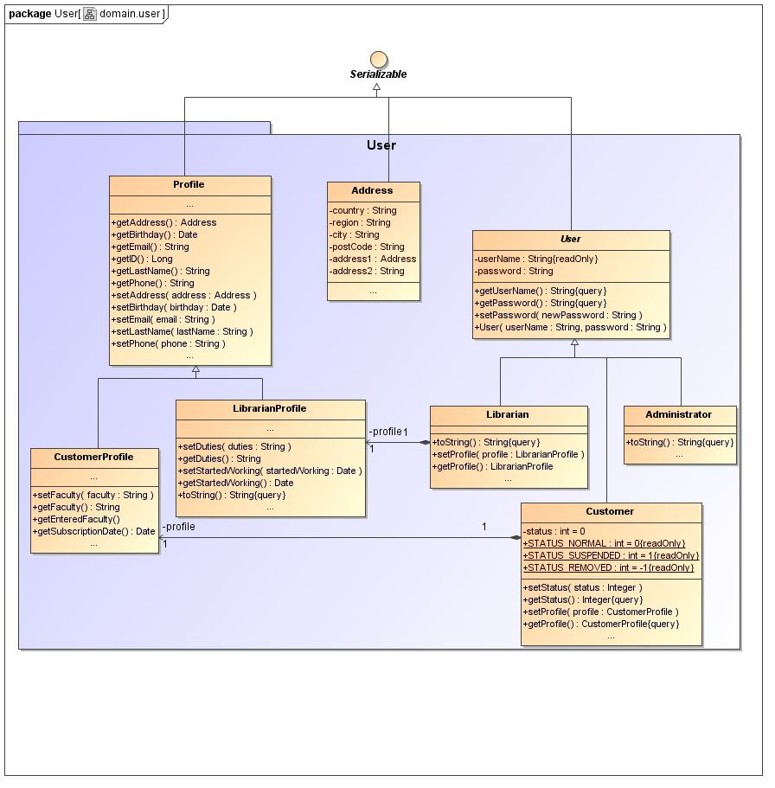
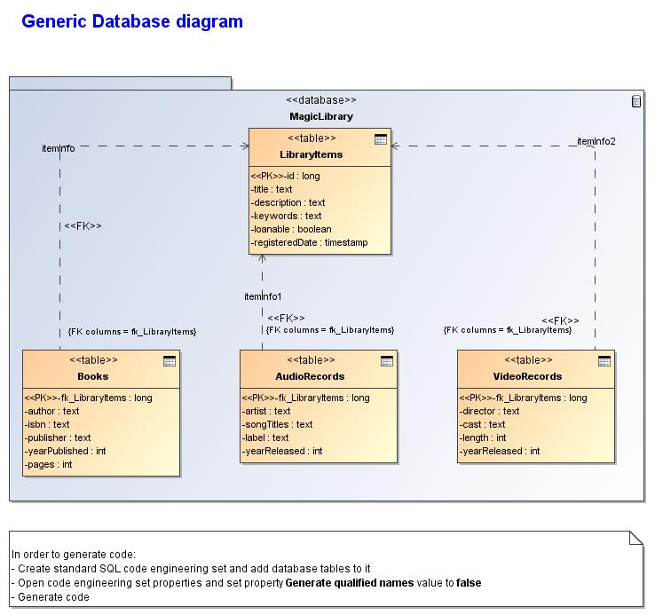
Model Use Case Report 2
Use Case Document for System name
Magic Library
Revision: 0
November 13, 2007

Approval
The original of this document is approved and signed by:
Name:
Surname:
Title:
Date:
Signature:
Revision History
Revision | Date | Description | Author
0 | November 13, 2007 | Initial version created. | No Magic

Table of Contents
Microsoft Word users please click here and press F9 to create Table of Contents.
OpenOffice.org users please remove this text and select Insert Table of Content from menu.

Index of Use-Cases
UseCase | UC # | Page

